**IN-BASKET TIPS (**19 & 23 Nov 2020 tutorial: Tiffany Young, Biz. Operations Mgr., SCH Amb. Operations**)**

***CUSTOMARY QUESTIONS:***

* “How do I route efficiently?”
* “How do I respond to results efficiently?”
* “How do I do refill requests?”

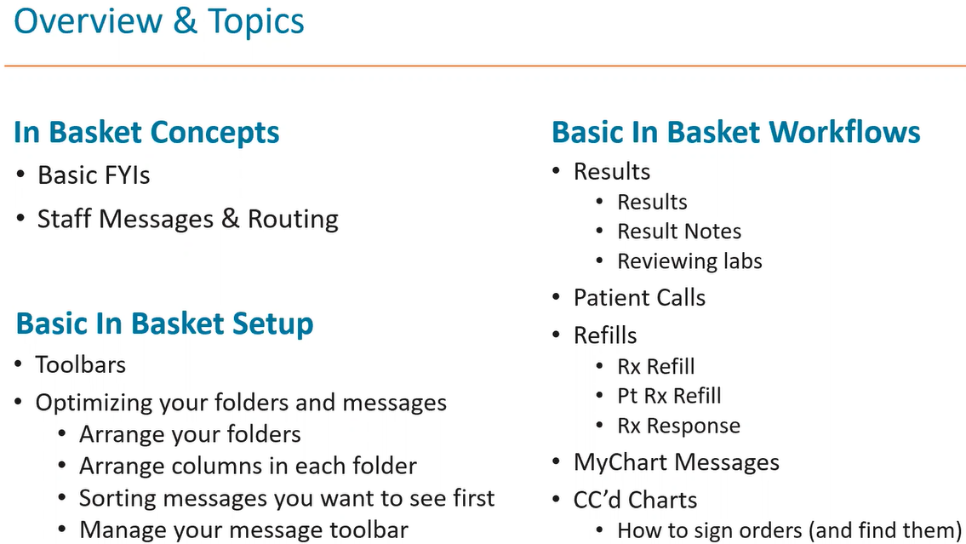

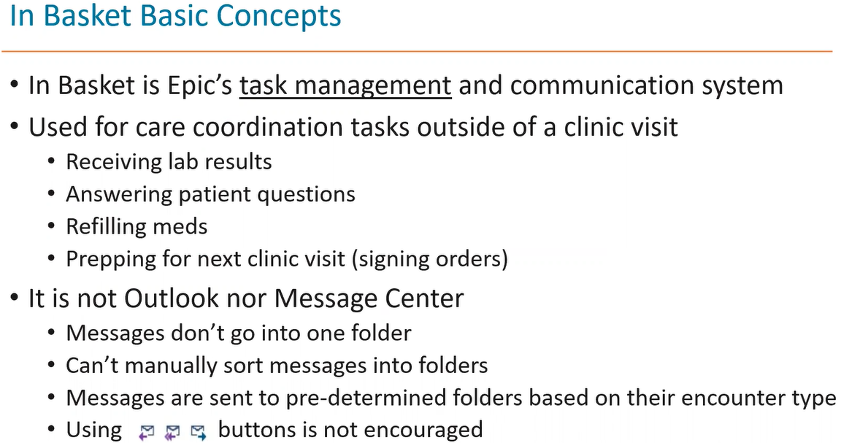

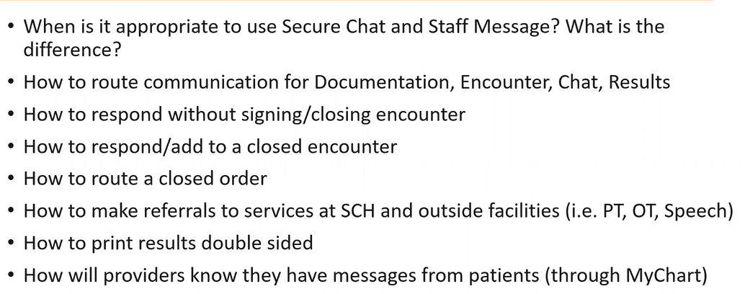

**Epic Hyperspace Toolbar:** *This is where to access inpatient, outpatient, and reporting activities*



**Wrench:** *Lets me customize my Toolbar for the activities I use most often. It’s always present.*

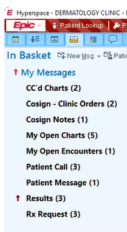 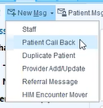

**Staff Message** (part of In Basket Toolbar)**:** *Select ‘****New******Msg****’ and it automatically generates a Staff Message. Remember: Staff Messages aren’t saved to the patient’s chart.*

**Patient Call Back:** *For front-desk who get clinical questions while scheduling appts. She will then send to the NDV pool, who assesses, and either then adds to an existing encounter (if it’s a continuation of such) or will initiate a new encounter*

**Staff Message “Drop-down list”:** *These are different flavors of staff messages.*

**In Basket Toolbar:***. It’s always present no matter where I am in In Basket.*

**Places you can initiate a PATIENT message: *Edit Pools:*** *If I’m part of a pool.*

***Search:*** *Search the In Basket for messages related to a patient. If I responded to a message, but don’t recall which folder I sent it to, go here, and search patient, and I’ll see all messages related to that patient.*



**My tasks:** *Each represents a task I need to address. Each of these is called “****Folder****”, and each contains* ***“Message Lists”****.*

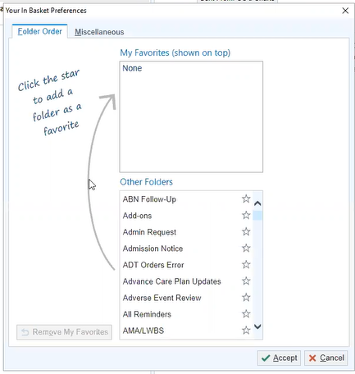

**Preferences:** *It’s in the* ***In Basket Toolbar****, and lets me move the* ***Message Folders*** *that I go thru more frequently to the top.*

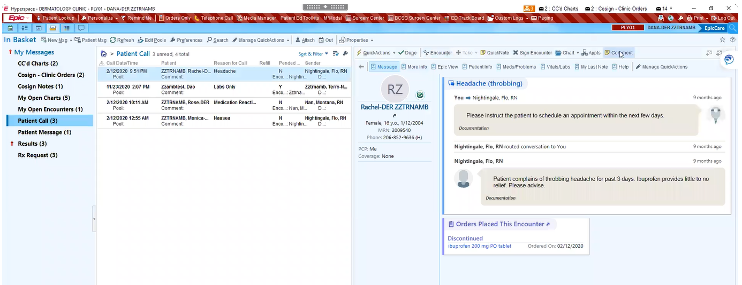

**Two Toolbars:**

1. ***Action Toolbar:*** *This lets me take an action on the message being sent to me. Each Action Toolbar is “curated” to the* ***Folder*** *type. So, a Patient Call folder has a differently designed Action Toolbar than does a* ***Results*** *folder.*

**Message List:** *I have 4 messages in this* ***“Message List”*** *that is within the Patient Call* ***“Folder”*** *in my In Basket.*

**Report Toolbar:** *In each of the Messages, there is a* ***Report Toolbar.*** *These are snippets of info within the patient’s chart without my having to enter the chart itself.*

**Chart Review:** *If I prefer to get into the patient’s chart, rather than get snippet of info by Report Toolbar, click on patient name*

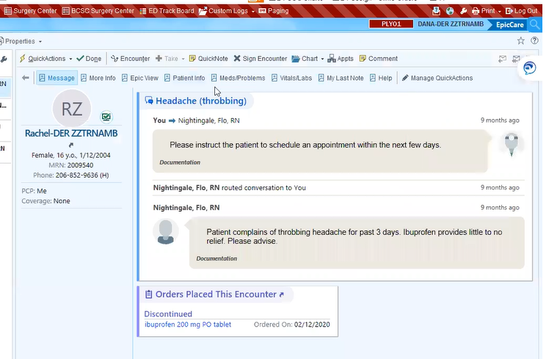

***WHEN TO SIGN ENCOUNTERS:***

* *Did you create the encounter?*:
  + NO: 🡪 *DON’T SIGN IT (other people are involved and may not be done with it)*
    - Send and Close the Workspace instead (or just sign out)
    - I do route. But signing is only for once all T’s crossed.

***SECURE CHAT*** vs. ***STAFF MESSAGE:***

* *Similarities*: The message is not saved to the patient’s chart
* *Differences*:
  + LIFESPAN
    - Secure Chat = 72 hours
    - Staff Message = 60 days

***STAFF MESSAGES:*** See “Two areas of great confusion” slide, below

* To create one, go to ***In Basket*** and then select ***New Msg***
  + A drop-down list of options lets me pick the “flavor” of the Staff Message
* It is OK (but not preferred) to use Staff Messages
  + Should be related to patients (and you can attach a patient chart to the Message)
  + Staff Messages will NOT save to the chart!!! (deletes after 60 days)

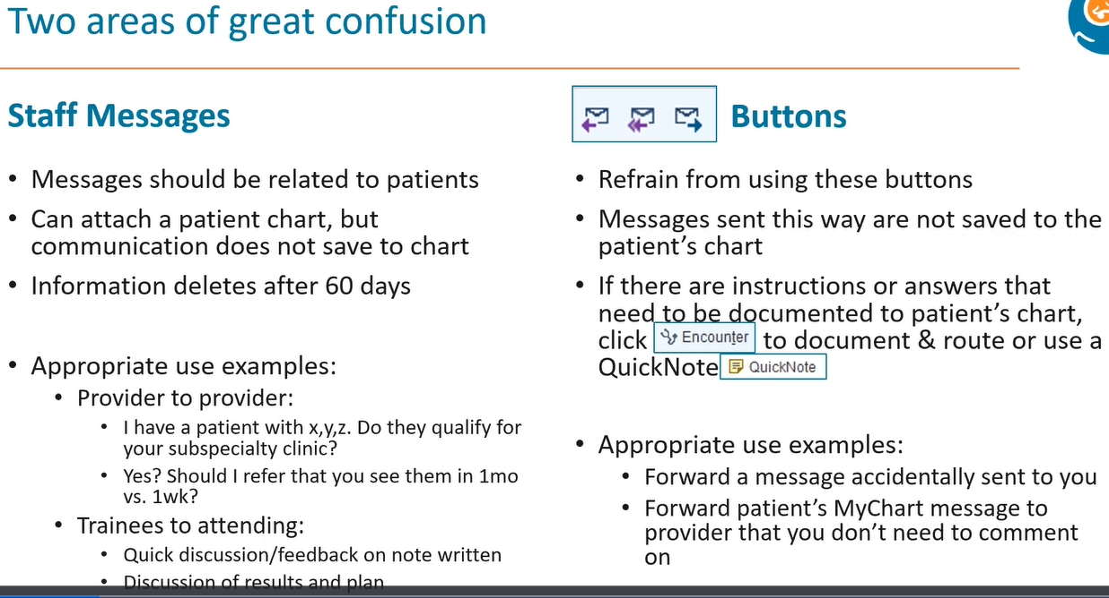

Staff messages

Reply/Forward Buttons

***REPLY, REPLY ALL, FORWARD Buttons:*** Don’t use these (except in the instances noted above):



* Reply, Reply All, and Forward messages will NOT save to the chart!!!
* Instead, you should: **WRITE A NOTE AND SAVE IT TO THE CHART:**

***TO WRITE A NOTE AND SAVE IT TO THE CHART*:**

EITHER:

* + **ENCOUNTER** button
    - (2) Document my note
      * (3) Route it

OR

* + **QUICKNOTE** button (not to be used if I must sign an order)
    - (2) Document my note
      * (3) Route it

***3 notes that do NOT appear in the patient’s “MyChart”:***

*But be careful! Everything in Epic is STILL discoverable, if subpoenaed!*

1. *Telephone Call*
2. *Documentation*
3. *Orders Only*
4. (and neither do “Secure Chat” or “Staff Message”, but these aren’t Notes)

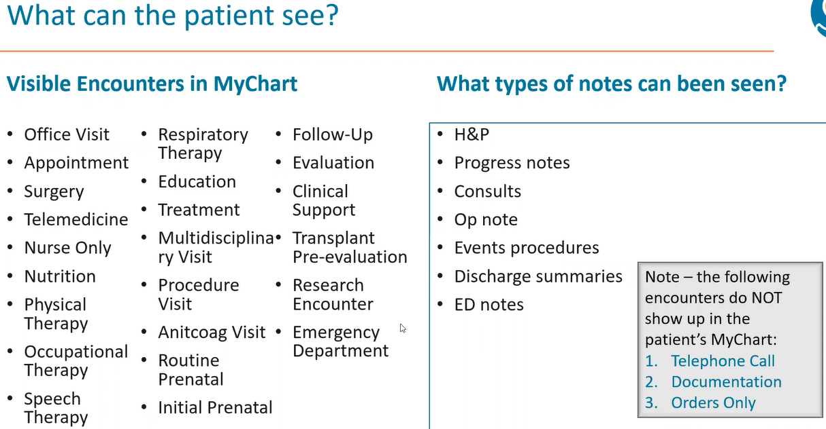

**However**, you can CHOOSE to not share your note to the patient’s chart (i.e., have it so that the patient cannot see the note) by clicking on that little **pink heart icon** at the top right of that note.

***RESULTS***



**Results**, to write my **Result Note….**

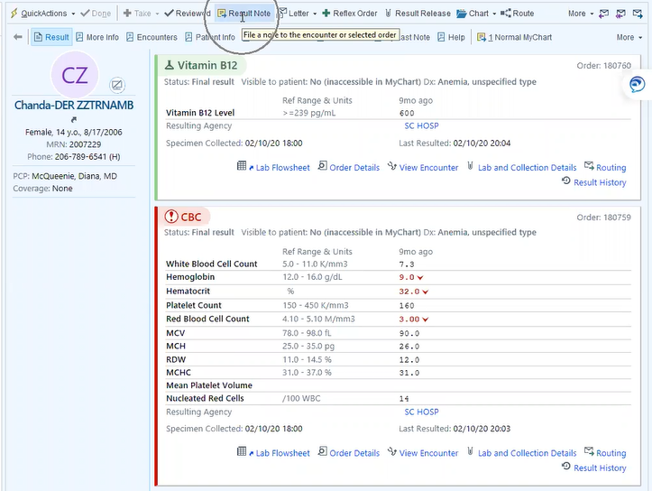

**MyChart Comment:** Write a message to the family here.

**Result Note**, Select it (let’s me state an interpretation of the lab result), and write my interpretation here.

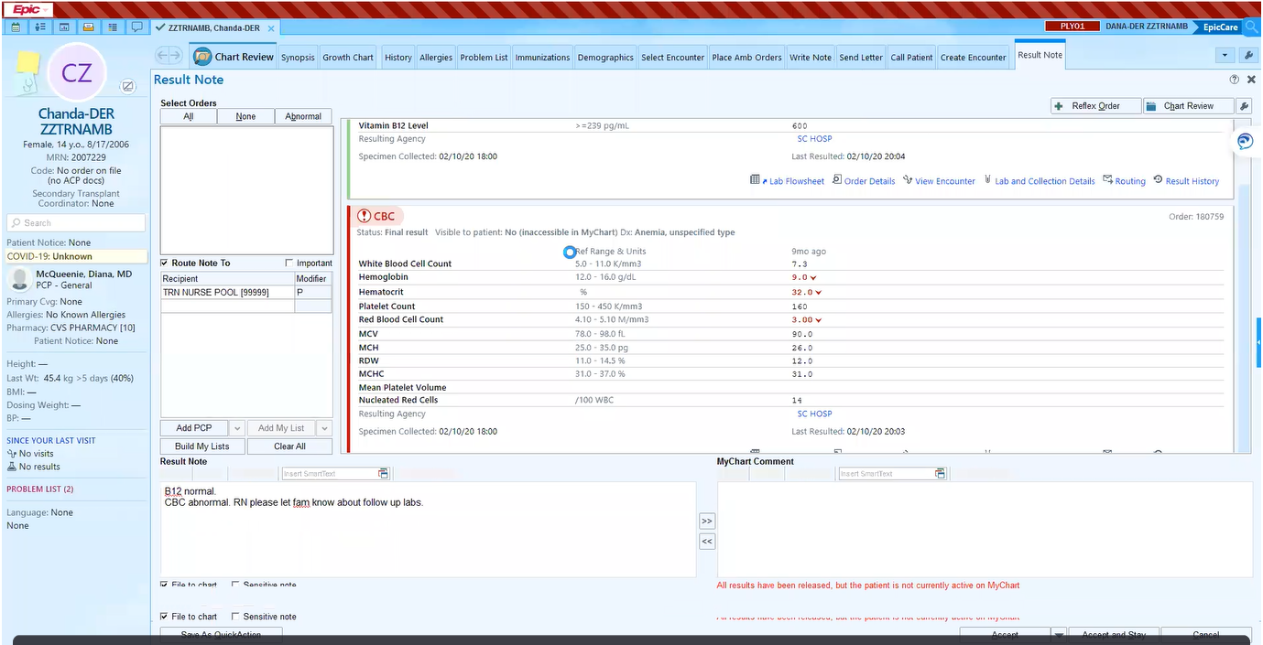

**Route Note To:** Send to the nurse (to tell her to, for example, let family know results.

**File to chart:**